28.25: As in Exercise 28.24, there is no contribution from the straight wires, and now we have two oppositely oriented contributions from the two semicircles:
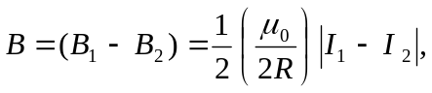
into the page. Note that if the two currents are equal, the magnetic field goes to zero at the center of the loop.

